

Foundations of Programming
Assignment No. : 13

PROBLEM STATEMENT:
Write a program in C to accept a number from the user and print the digits of the number in reverse order.

OBJECTIVE:
• To understand number manipulation using loops
. • To learn the use of modulo (%) and division (/) operators.
• To implement logic for reversing digits of a number.
• To improve problem-solving skills using iterative structures.
THEORY:
• To understand number manipulation using loops. • To learn the use of modulo (%) and division (/) operators. • To implement logic for reversing digits of a number. • To improve problem-solving skills using iterative structures.

PLATFORM:
Linux

ALGORITHM:
1) Start
2) Accept a number from the user and store it in variable num.
3) If num == 0:
- Print 0
- Stop
4) Else:
- If num < 0:
  - Print - (minus sign)
  - Make num positive: num = -num
- While num > 0:
  - remainder = num % 10
  - Print the remainder
  - num = num / 10
5)Stop

FLOWCHART:

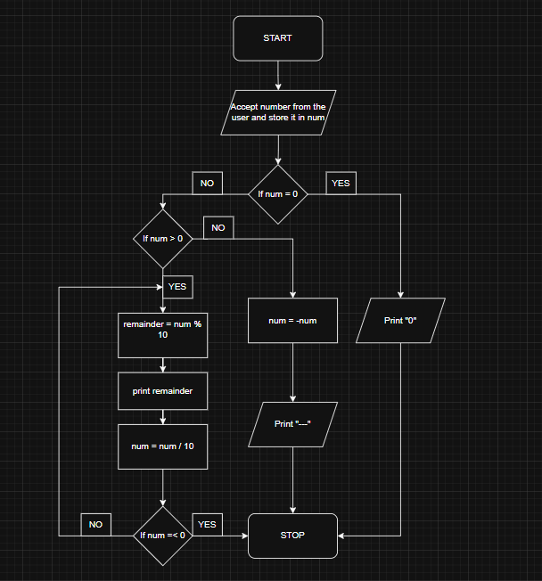

C PROGRAM:
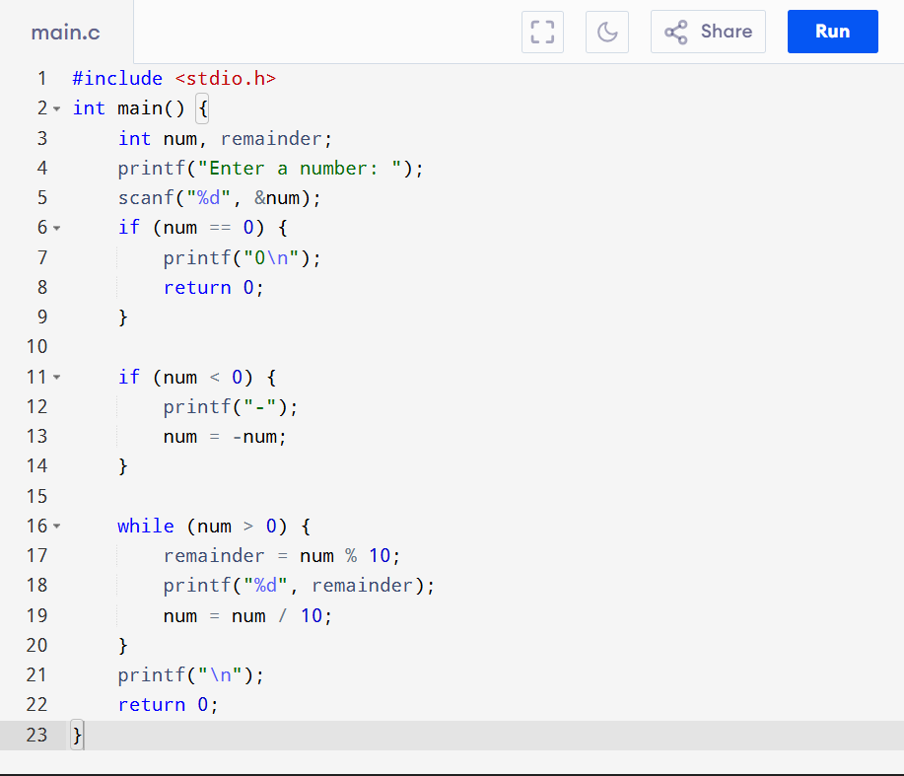

INPUT:
The user enters an integer number.
Example Input: Number: -891 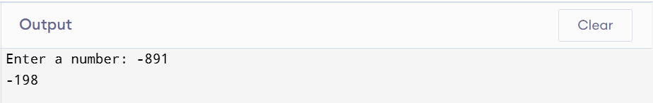

OUTPUT:
The program prints the digits of the number in reverse order.
Example Output: Digits in reverse order: -198 

CONCLUSION:
Thus, the program to print the digits of a number in reverse order was successfully implemented using C programming. The program demonstrates the effective use of loops, modulo operator, and division operator.

FAQs:
- Why is the modulo operator (%) used in this program?
- Why is division by 10 used after extracting each digit?
- What happens if the input number is zero?
- How will the program behave for negative numbers?
- Why is a while loop preferred for this operation?

